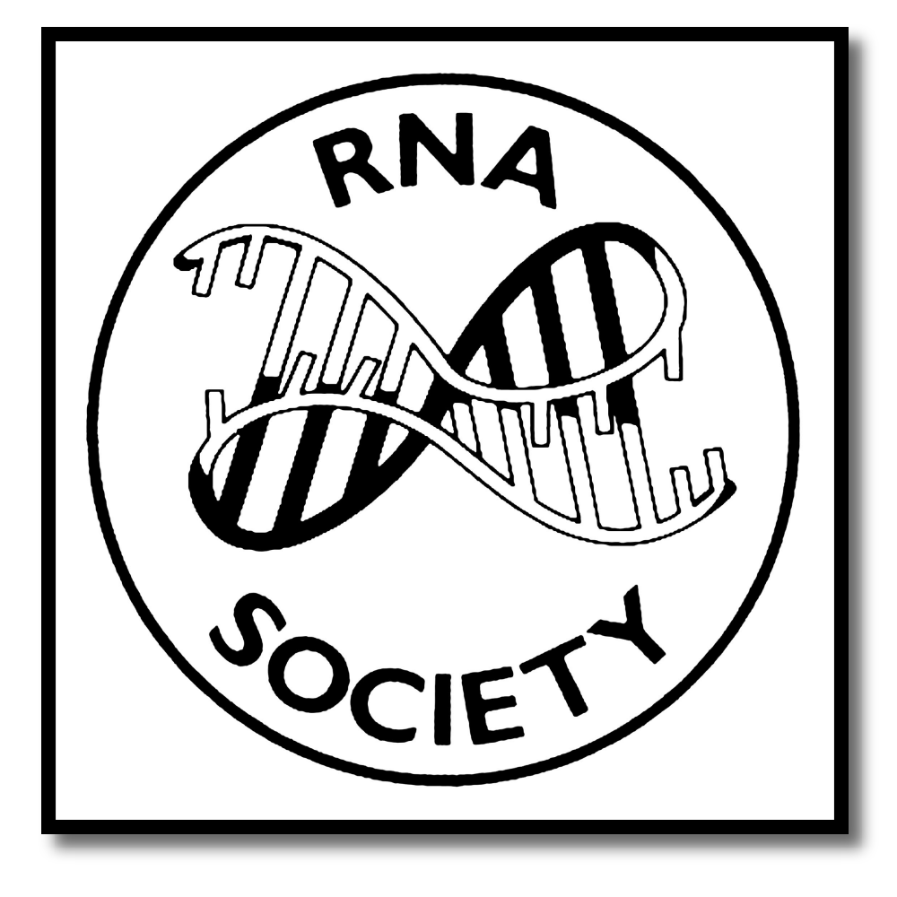
The RNA Society/Scaringe
Young Scientist Award

The RNA Society/Scaringe Young Scientist Award was established to recognize the achievement of young scientists engaged in RNA research and to encourage them to pursue a career in the field of RNA. The award is open to all junior scientists (graduate students or postdoctoral fellows) from all regions of the world who have made a significant contribution to the broad area of RNA. The award is not restricted to authors who have published in the RNA Journal. The prize will recognize one outstanding graduate student and one postdoctoral fellow based on their research accomplishments to date, a 7000-character essay describing their scientific contributions to RNA research, and a 2500-character abstract for a review in their field of RNA research.

Judging Procedures:
All applications are evaluated by the RNA Society Awards Committee. The applicants will be divided into one of two groups: graduate students or postdoctoral fellows. Applications will be judged on the quality of the research and the entrant's ability to articulate his or her research contributions to the field of RNA. This committee will choose one graduate student and one postdoctoral fellow winner prior to the abstract deadline for the annual meeting.

Prizes:
The winners’ names will appear in the abstract book and their expenses associated with attending the meeting will be reimbursed. The winners will receive a cash prize and a one-year membership to the RNA Society that includes a subscription to the journal RNA. By accepting the prize, the winner agrees to write a mini-review or review for RNA. The review can be written solely by the winner or in collaboration with their advisor.

Application procedure:

- Complete this form using Microsoft Word by typing your text into the gray boxes, which will expand as you write.

- Name the completed form as LastName_Scaringe.doc

Upload this completed application and complete the form located at : https://www2.rnasociety.org/the-rna-society-scaringe-young-scientist-award/
Please note that it is your responsibility to make sure the PI sends a letter by the application due date.

Deadline:
Only completed applications submitted by October 1st 2020 will be considered.
Application Form

First Name

Last Name
Institution
Mailing Address
City
State
Country
Postal/Zip Code
Phone
Email

Only completed applications submitted by October 1st 2020 will be considered.

Please note that due to time constraints on the review process, the RNA Society Award Committee, The RNA Society, and the Scaringe Foundation cannot provide any feedback to applicants before, during or after the review process.

- Education. Please list your undergraduate and graduate education.

INSTITUTION AND LOCATION | DEGREE  (if applicable) | YEAR(s) | FIELD OF STUDY

B. Scientific positions held (if applicable). List in chronological order previous positions, concluding with your present position.

C. Honors & Awards received. List the academic and professional awards and honors you received as a student.

D. Selected peer-reviewed publications. List full citation, including title and authors for publication in chronological order. Do not include publications in preparation.

E. Presentations. List the type of presentation and title, location of presentation and date (for example, meeting title, location, date)

F. Summary of Research Accomplishments. Provide a summary of your past and present research accomplishments. Be sure to indicate how your work contributed to RNA research. THIS SECTION HAS A MAXIMUM CHARACTER LIMIT OF 7000 CHARACTERS. Longer text will be truncated at 7000 characters.

G. Abstract of a minireview or review in your field of RNA. This should include a brief description of the current state of the field to set up the questions that you would answer in your review. You should also provide the rationale for writing on this topic at this particular time (for example, the progress that has been made, how it relates to what is known and how it may affect future direction of the field). THIS SECTION HAS A MAXIMUM WORDS LIMIT OF 2500 CHARACTERS. Longer text will be truncated at 2500 characters.

H. Letter of support
Please ask your PI, or another PI familiar with your work, to provide a letter of support for your application to RNA Society/Scaringe Award. The form for the letter is supplied as a separate document.

